SUMMERVILLE CREDIT UNION · CONSOLIDATED MEMBER GUIDE · CSUM-10 of 30
FedNow Instant Pay

Module: nFinia Digital Banking > Move Money > FedNow Instant Pay
Sources: Summerville Reports Series A (36 docs) + Series B (25 docs) | Features: nFinia Documentation Features Spreadsheet
01 PRODUCT SUMMARY

FedNow / Send Instantly enables members to send money in seconds, 24 hours a day, 7 days a week including holidays, using the Federal Reserve's real-time payment network and/or The Clearing House RTP network. Unlike ACH which batches transactions, FedNow settles funds immediately and irrevocably.
Because FedNow payments are final and cannot be reversed once sent, the platform requires members to review and accept terms and conditions before submitting. This protects members from accidental high-value transfers. Members must carefully verify recipient and amount details before confirming — there is no recall option once funds are sent.
Instant Pay History provides a log of all real-time payment transactions, giving members a chronological record of every FedNow and RTP payment sent or received through the platform.

At a Glance

Attribute | Detail
Module | Move Money > FedNow Instant Pay / Send Instantly
Network | Federal Reserve FedNow + The Clearing House RTP
Settlement Speed | Seconds — 24/7/365 including weekends and holidays
Reversibility | Irrevocable — cannot be recalled once sent
Steps | 4 (From → Amount/Recipient → Terms → Final Confirm)
Related Reports | CSUM-06 (Move Money Hub), CSUM-09 (ACH Transfer)

02 KEY USE CASES

Use Case | Who Uses It | What They Do | Business Value
Urgent Payment Delivery | Members needing immediate fund delivery | Use FedNow for same-second settlement for time-critical payments | Eliminates 1–3 day ACH wait for urgent situations
Weekend/Holiday Transfer | Members needing off-hours transfer | FedNow operates 24/7 including weekends and federal holidays | No need to wait for next business day
Large Urgent Payment | Members with high-value time-sensitive payments | FedNow processes large amounts instantly with T&C confirmation | Real estate deposits, contractor disbursements, urgent invoices
Instant Confirmation | Members needing immediate proof of payment | FedNow confirmation is immediate with a reference number | Verifiable instant receipt for payer and recipient

03 STEP-BY-STEP GUIDE

Navigation: Dashboard > Move Money > 'FedNow Instant Pay' OR 'Send Instantly'.
Step 1 — Start from Dashboard
The member begins at the Dashboard after logging in. The Dashboard displays all account balances, upcoming payments, quick-action tiles, and the top navigation bar with links to Accounts, Move Money, and More.
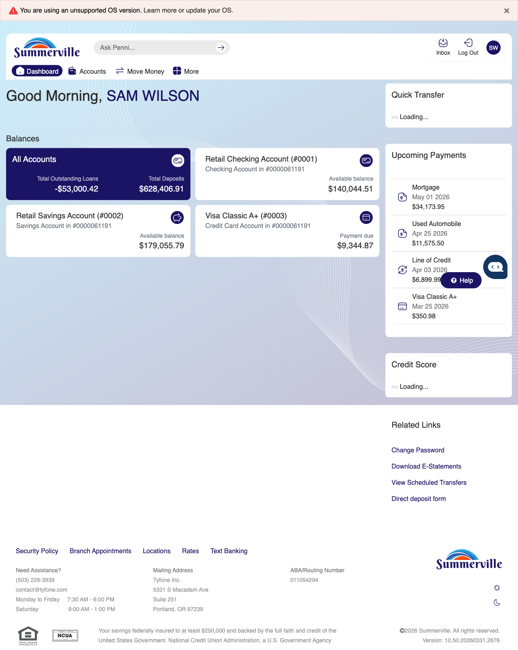
Step 1: Start from Dashboard

Step 2 — Navigate to Move Money Hub
The member clicks ‘Move Money’ in the top navigation bar. The Move Money Hub displays all payment and transfer options as tiles including Pay Bills, Quick Pay, Zelle Payment, Internal Transfers, Other Members, Same-Day Transfers, Send Instantly, Manage Recipients, Add Recipient, Transaction History, Scheduled Transfers, and P2P Transfer.
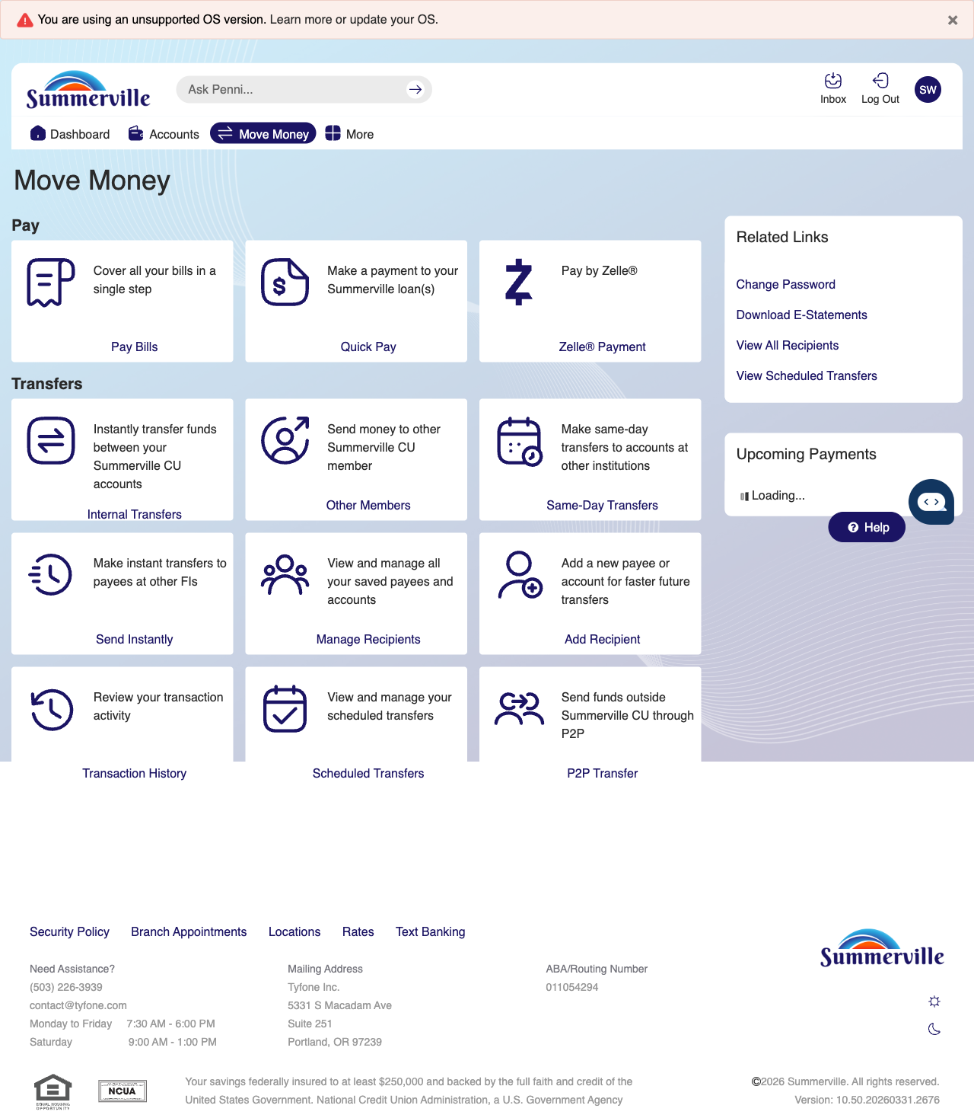
Step 2: Move Money Hub

Step 3 — Navigate from Dashboard to FedNow
The Move Money hub is shown as the landing page for initiating a FedNow Instant Payment transfer.
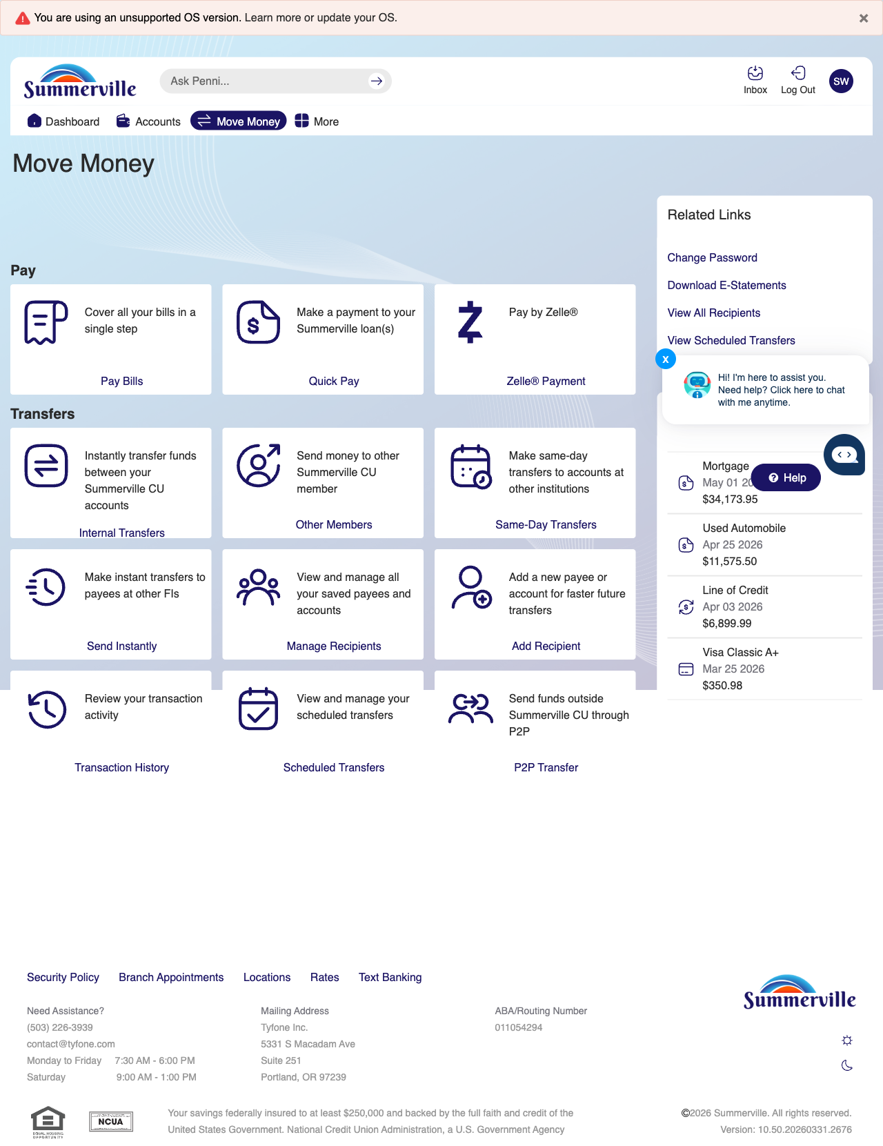
Step 3: Navigate from Dashboard to FedNow

Step 4 — Fill Payment Form
Step 2 of the FedNow transfer shows a form with fields for entering transfer details and recipient information for the instant payment.

Step 4: Fill Payment Form

Step 5 — Review & Accept Terms
The FedNow Terms and Conditions page is displayed with checkboxes for accepting the agreement before proceeding with the instant payment.
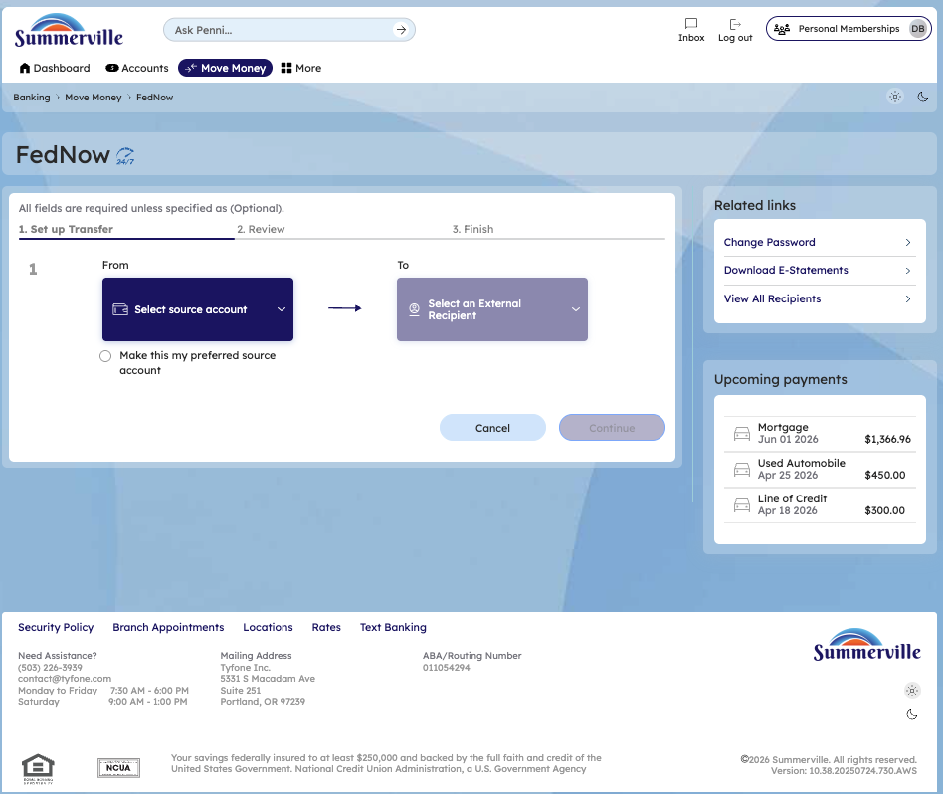
Step 5: Review & Accept Terms

Step 6 — Final Confirmation & Send
The final confirmation screen shows a FedNow instant transfer of $1,000 with full transaction details and a confirmation button to complete the payment.
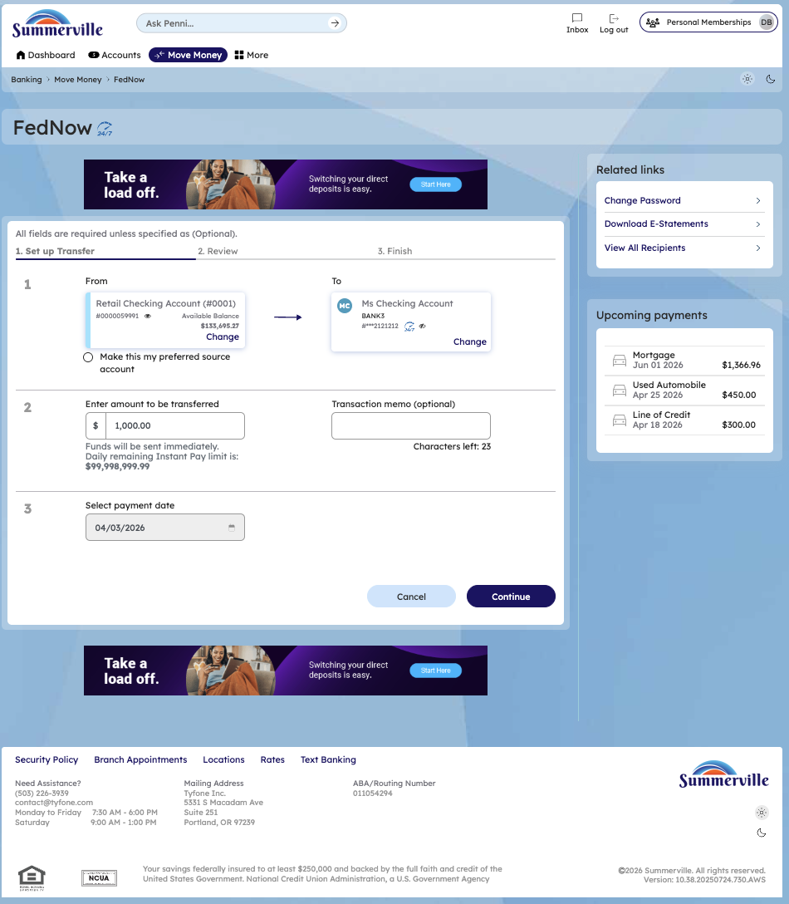
Step 6: Final Confirmation & Send

